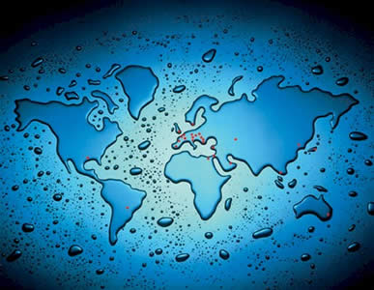

**Water World**

**Name: _________________________**

**Class: _______________**

**Contents**

|  |  |
| --- | --- |
| Page |  |
| 3 | How Does London Use Water? |
| 5 | Where In The World Is All The Water? |
| 8 | Where Does Water Come From? |
| 10 | What Happens When Water Reaches The Ground? |
| 13 | What Are The Causes Of Flooding? |
| 15 | How Can We Cope With Flooding? |
| 18 | Why Does Ahmed Need New Shoes? |
| 21 | Do We All Have The Right To Clean Water? |
| 23 | Water – A Cause Of Conflict |
| 28 | Bottled Water – Fact Or Opinion |
| 33 | Water Aid |
| 35 | Will Our Water Run Out? |

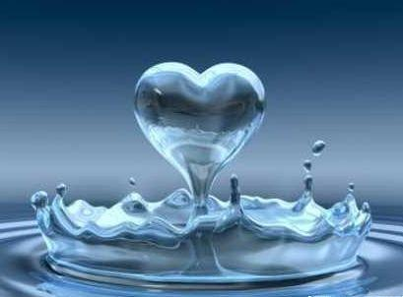

Look at the image of London. Annotate it with as many famous landmarks as you can name:

**How Does London Use Water?**

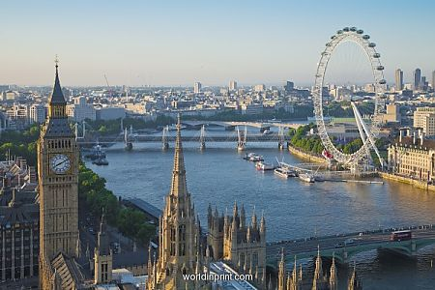

Complete the spider diagram below with ways that London uses water. Think of your own daily routine as well as why some people may visit the city:

Drinking

Flushing The Toilet

Look at the table below and rank the top three uses of water in your house:

|  |  |  |  |
| --- | --- | --- | --- |
|  | **Rank One** | **Rank Two** | **Rank Three** |
| **Drinking** |  |  |  |
| **Bath** |  |  |  |
| **Shower** |  |  |  |
| **Brushing Teeth** |  |  |  |
| **Cleaning** |  |  |  |
| **Cooking** |  |  |  |

Now ask your classmates the same question and add them to your table.

In the space below draw a staked bar graph to how your results:

Write three paragraphs to explain your findings. Some sentence starters have been given to help you:

My results show that most people in my geography class use water at home for_______________. I know this because _____ people out of a class of _____ chose this in my questionnaire.

________________________________________________________________________________________________________________________________________________________________________________________________________________________________________________________________________________________________________________________________________________________________________________________________________________________________________________________________________________________________________________________________________________________________________________________________________________________________________________________________________________

Why do you think it’s important to study water?

______________________________________________________________________________________________________________________________________________________________________________________________________________________________________________________

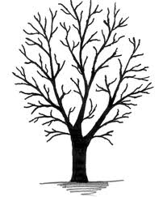Most water that falls on land as rain eventually finds its way into a river. This is an important part of the **Hydrological Cycle** - you will look at in more detail in a later lesson. Rain is a type of **transfer** whilst the river is a **store**.

**Where In The World Is All The Water?**

If you look at the top of a large tree you will see lots of twigs. Twigs are small branches. If you follow these downwards, you will see these twigs joining to form branches. These branches join to form one big trunk.

A **river** is like a tree. It has lots of small streams which join to form **tributaries** which later join to form the main river. When it rains, most of the water slowly drains into streams, then into tributaries and finally into the main river. The **river basin** is the area of land drained by a main river and its tributaries.

Although rivers differ in many ways, they all have similar features. Below is a diagram of the key features of the river:

◊ First, identify the key features and write them in the boxes:

Watershed Source River Basin Tributary Channel Mouth

◊ Second, draw a line from the key features to the correct definition to give their meanings

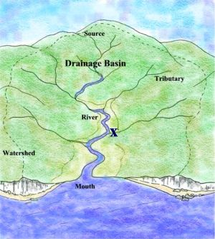

is where the river begins

is where the river flows

is where the river flows into a lake or the sea

is an area of highland forming the edge of a river basin

is a stream or small river flowing into a main river

is an area of land drained by a river and its tributaries



*Did You Know?*

*Every year the world’s rivers carry about 10 billion tonnes of material to the sea*



*Did You Know?*

*Water is the most common substance on Earth but less than 1% is in rivers - 97% is in oceans and that’s salty!*

*Did You Know?*

*The rain that falls on you has fallen millions of times before - It could have fallen on a dinosaur or Cleopatra*

Thirteen important world rivers are, in alphabetical order:

|  |  |  |  |  |
| --- | --- | --- | --- | --- |
| The Amazon | Colorado | Danube | Ganges | Murray-Darling |
| Mississippi | Nile | Rhine | St Lawrence | Volga |
| Yangtze |  | Zambezi |  | Zaire (Congo) |

Fit the names into the crossword below. The number of letters will help you fit them into the puzzle. For example, the Murray-Darling, which has been done for you, was the only word with 13 letters. It could only fit in one place.

2

1

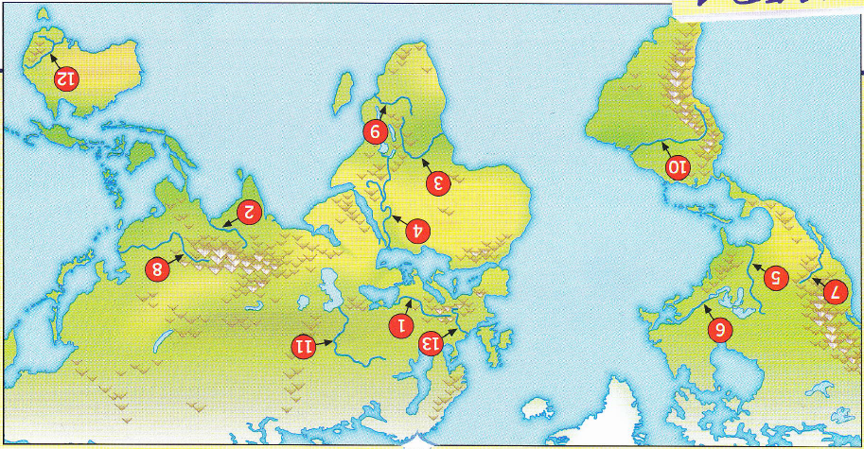

The map below, and the puzzle above, will help you to name and locate the rivers:

8

13

12

11

10

9

7

6

5

4

3

G

N

I

L

R

A

D

Y

A

M

R

R

U

M

Using the map and an atlas if you need one, complete the table below with some of the information about these important rivers:

|  |  |  |  |  |  |
| --- | --- | --- | --- | --- | --- |
| Number | Name Of River | Continent | Country Of Source | Sea Of Mouth | Length |
| 1 |  |  |  |  |  |
| 2 |  |  |  |  |  |
| 3 |  |  |  |  |  |
| 4 |  |  |  |  |  |
| 5 |  |  |  |  |  |
| 6 |  |  |  |  |  |
| 7 |  |  |  |  |  |
| 8 |  |  |  |  |  |
| 9 |  |  |  |  |  |
| 10 |  |  |  |  |  |
| 11 |  |  |  |  |  |
| 12 |  |  |  |  |  |
| 14 |  |  |  |  |  |

Rivers are important to people because they provide water, are used for transport and can be used to provide power. Look at the photos on the next page and give a description of what the river is being used for:

|  |  |
| --- | --- |
| Photo Number | What The River Is Being Used For |
| 1 |  |
| 2 |  |
| 3 |  |
| 4 |  |
| 5 |  |
| 6 |  |

|  |  |
| --- | --- |
| 1.  http://t0.gstatic.com/images?q=tbn:ANd9GcQCMtc2vdTj_3BvTS3P_fwbslhWrf2_IzlOXD4JtSfrcqAKcGbRRcSDjo8c | 2.  http://shipbright.files.wordpress.com/2010/02/praying-in-the-ganges.jpg |
| 3.  http://www.hobotraveler.com/uploaded_images/207-92-togo-children-washing-clothes-734402.jpg | 4.  http://www.internationalrivers.org/files/images/4213xiluodu1.jpg |
| 5. | 6.  http://www.globocation.com/wp-content/uploads/2011/11/picture-of-raft.jpg |

**Where Does Water Come From?**

What percentage of these items do you think are water?

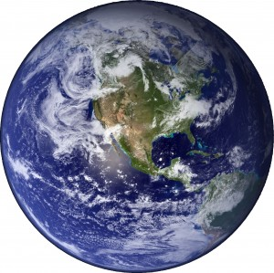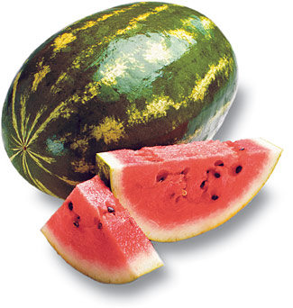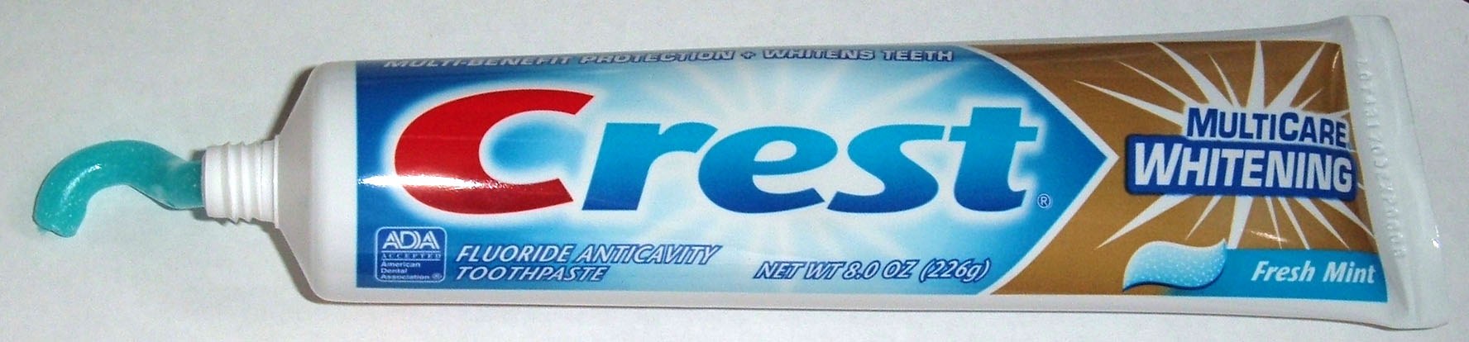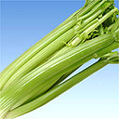

The water cycle is the never ending movement of water between the ocean, atmosphere and land. Some of the water may be stored in the ocean, on land or in the atmosphere. This water will be transferred around the system.

On the copy of the hydrological cycle below fill in the gaps using the following terms:

Evaporation Percolation

Through Flow Precipitation

Infiltration Surface Runoff

Interception Water Table

Overland Flow

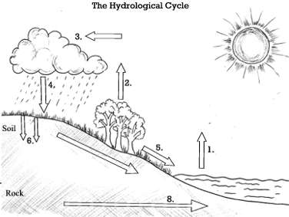

Write your own definitions for the following:

Evaporation:_________________________________________________________________________________________________________________________________________________________

Condensation:________________________________________________________________________________________________________________________________________________________

Transpiration:________________________________________________________________________________________________________________________________________________________

In no more than 6 steps, explain how water is transported around the Earth

______________________________________________________________________________________________________________________________________________________________________________________________________________________________________________________________________________________________________________________________________________________________________________________________________________________________________________________________________________________________________________________________________________________________________________________________

Write a diary or story of the journey of a water droplet around the hydrological cycle:

____________________________________________________________________________________________________________________________________________________________________________________________________________________________________________________________________________________________________________________________________________________________________________________________________________________________________________________________________________________________________________________________________________________________________________________________________________________________________________________________________________________________________________________________________________________________________________________________________________________________________________________

**What Happens When Water Reaches The Ground?**

Match the key words to the correct definitions:

|  |  |  |
| --- | --- | --- |
| Ground Water  Impermeable  Infiltrate  Permeable  Surface Runoff |  | Does not allow water to pass through |
|  | Does allow water to pass through |
|  | Water which runs over the lands surface |
|  | When water passes through soil |
|  | Water that has drained through surface layers of rock until it reaches a layer which it can’t pass |

In groups you are going to investigate how different surfaces react to water.

Each group will be given a 2 litre bottle of water and carry out research at different locations of the school site. You will individually need to record your results so you can write up your report later

You need to make sure you record exactly what happens in the boxes provided, using as many of the key words you have learnt above:

|  |  |  |  |  |  |
| --- | --- | --- | --- | --- | --- |
| **Date:** | | **Equipment:** | | **Weather:** | |
| **Location A =** | **Location B =** | | **Location C =** | | **Location D =** |
| **What happens to water when it lands on a flat tarmac surface (location__)?** | | | | | |
| **What happens when water lands on a sloped tarmac surface (location__)?** | | | | | |
| **What happens when water lands on a flat grassy surface? (location__)?** | | | | | |
| **What happens when water lands on a sloped grassy surface (location__)?** | | | | | |
| **What happens to water when it falls quickly or heavily on a surface (location__)?** | | | | | |
| **What happens to water when it falls slowly or gently on a surface (location__?)** | | | | | |

When you write up your fieldwork enquiry it is very important to include as much detail as possible. Also, to use as much vocabulary (key words) as you can. The writing frame below will help you. Use the sentence starters and questions to write a report in your book of your finding. Include:

◊ the **method** you used to collect information

◊ a **description** of what you found out

◊ an **explanation**, giving reasons for what you found out

|  |
| --- |
| **METHOD – Describe how something is done in sequenced steps**  For our enquiry we wanted to find out __________________________________________________  __________________________________________________________________________________  The equipment we used was __________________________________________________________  __________________________________________________________________________________  The four different locations we chose around the school grounds were ________________________  ________________________________________________________________________________________________________________________________________________________________________________________________________________________________________________________________________________________________________________________________________  At each of the four locations we observed what happened when _____________________________  __________________________________________________________________________________  The drawing below show what we did:  **DESCRIPTION – Say what a feature, object or process is like, in a logical way**  I have drawn a table that shows _______________________________________________________  The places where the water infiltrated most quickly were ___________________________________  __________________________________________________________________________________  The places were the water infiltrated most slowly were _____________________________________  __________________________________________________________________________________  Surface runoff happened where/when __________________________________________________  __________________________________________________________________________________  **EXPLAINATION – Give reasons for how or why something happens**  What happens to water when it reaches the ground is affected by many things including __________  ______________________________________________________________________________________________________________________________________________________________________________________________________________________________________________________  The water is most likely to infiltrate on _______________ and _______________surfaces and when it falls _____________________________________________________________________________  ____________________________________________________________________________________________________________________________________________________________________  This is because _____________________________________________________________________  ____________________________________________________________________________________________________________________________________________________________________  Another reason for this is _____________________________________________________________  ____________________________________________________________________________________________________________________________________________________________________  Finally, water also infiltrates because ___________________________________________________  ____________________________________________________________________________________________________________________________________________________________________  Water is most likely to runoff on _______________ and _______________surfaces and when the water falls _________________________________________________________________________  ____________________________________________________________________________________________________________________________________________________________________  This is because _____________________________________________________________________  ____________________________________________________________________________________________________________________________________________________________________  Another reason for this is _____________________________________________________________  ____________________________________________________________________________________________________________________________________________________________________  Finally, water also runoffs because _____________________________________________________  ____________________________________________________________________________________________________________________________________________________________________ |

The sentences below explain how a flood happens, but they are in the wrong order. Rearrange them into the correct order…

**What Are The Causes Of Flooding?**

__ The river floods

__ The grounds becomes soaked

__ More rain runs over the ground and into the river

__ Lots of rain falls for a long time

__ The water flows over the sides (banks) of the river

__ The water can’t soak into the ground (infiltrate)

There are lots of reasons which can lead to flooding. Add tot eh spider diagram as many reasons as you can think of making sure you list them as either human or physical reasons:

Human

Physical

Watch the video on the website below of the 2010 Queensland Floods:

<http://www.guardian.co.uk/environment/2011/jan/11/australia-floods-la-nina>

How does it make you feel to watch the video?

______________________________________________________________________________________________________________________________________________________________________________________________________________________________________________________

How would you feel in that situation?

______________________________________________________________________________________________________________________________________________________________________________________________________________________________________________________

What effect do you think it would have had on social, economic and environmental factors?

__________________________________________________________________________________________________________________________________________________________________________________________________________________________________________________________________________________________________________________________________________________________________________________________________________________________

Think about the affects you have seen and read in the Queensland Floods video.

Add these to the Venn diagram to show whether they are social, economic or environmental effects – Some may overlap into two headings

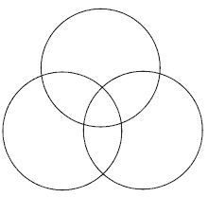

Social

Environmental

Economical

On the next page write a news report script explaining how the Queensland's floods occurred and its impacts on the population and surrounding area.

Remember to include:

◊ Date

◊ Location

◊ Social Impacts

◊ Environmental Impacts

◊ Economic Impacts

◊ Personal Experiences

______________________________________________________________________________________________________________________________________________________________________________________________________________________________________________________________________________________________________________________________________________________________________________________________________________________________________________________________________________________________________________________________________________________________________________________________________________________________________________________________________________________________________________________________________________________________________________________________________________________________________________________________________________________________________________________________________________________________________________________________________________________________________________________________________________________________________________________________________________________________________________________________________________________________________________________________________________

**How Can We Cope With Flooding?**

The Thames Barrier – The Facts:

◊ The Thames Barrier is the second largest movable flood barrier of its kind in the world

◊ It is often thought of as the eighth wonder of the world

◊ It took 8 years to build and was completed in 1982

◊ 11.5 miles of the river bank has been protected by walls

◊ The barrier stretches across a width of 520m across the Thames

◊ The barrier has been raised over eighty times

◊ The barrier mainly protects the capital against sea surges

◊ High water has risen by 2.5 feet per century due to melting ice caps

◊ The last great flood was in 1952 when 300 people lost their lives and 160,000 acres of land were flooded

Work with your partner to research the different types of flood prevention we use. Hard engineering methods are man-made structures, whereas soft engineering tries to blend in with the aesthetics of the area:

|  |  |  |  |
| --- | --- | --- | --- |
| **Hard Engineering Methods** | **Description** | **Advantages** | **Disadvantages** |
| Embankments |  |  |  |
| Channelling |  |  |  |
| Dams |  |  |  |
| Flood Relief Channels |  |  |  |
| **Soft Engineering Methods** |  |  |  |
| Flood Plains |  |  |  |
| Afforestation |  |  |  |
| Land Use Zoning |  |  |  |
| Flood Warning Systems |  |  |  |



The Environment Agency has employed you to consider which flood prevention methods should be used in your local area.

There are four main areas which need to be protected. Use the information you have gathered above to decide which flood prevention methods should be used where and why.

Housing Estate:

◊ Large 1980s development with

3,000 houses and a population of

12,000

◊ Contains an infant and primary

school

◊ Contains a supermarket and shops

Trading Estate:

◊ 300 acres

◊ Companies on the trading estate

include: Mars Confectionary, Boat

Trader, Ford Motors, amongst

others

Main Road:

◊ The road can become very busy in

the mornings and afternoons with

school runs to the estate

◊ Around 7pm the road can become

busy with adults returning from

jobs in the nearest town,

Marshtown

Nature Reserve:

◊ 55 acres

◊ Mainly pinewood with other

deciduous trees

◊ Sphagnum bog

◊ Large variety for birds and wildlife

Annotate the map on the next page to show which prevention method you would use where and why:

The River Hickson

Main Road:

◊ The road can become very busy in

the mornings and afternoons with

school runs to the estate

◊ Around 7pm the road can become

busy with adults returning from

jobs in the nearest town, Marshtown

Trading Estate:

◊ 300 acres

◊ Companies on the trading estate

include: Mars Confectionary, Boat

Trader, Ford Motors, amongst

others

Housing Estate:

◊ Large 1980s development with

3,000 houses and a population of

12,000

◊ Contains an infant and primary

school

◊ Contains a supermarket and shops

Nature Reserve:

◊ 55 acres

◊ Mainly pinewood with other

deciduous trees

◊ Sphagnum bog

◊ Large variety for birds and wildlife

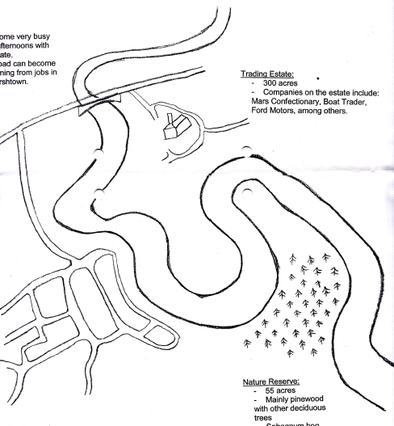

Ahmed is a poor Palestinian farmer living in Madama, 50km north of Jerusalem. As the only source of water in the village is frequently sabotaged by the Israelis, Ahmed has to walk to collect water from the Israeli Jewish settlement of Iraqburin. To get to Iraqburin, Ahmed has to pass a military check point. The journey takes two to three hours – much longer is the soldiers hold him up. Despite such long journeys, he often returns with no water. On occasions the soldiers do not let him pass and sometimes on the return journey they have emptied his water containers. Ahmed cannot afford the two dollars per cubic meter of water charged by the driver of the village’s tanker, who also collects water from Iraqburin and delivers to the wealthier inhabitants of Madama.

**Why Does Ahmed Need New Shoes?**

The two thousand inhabitants of Madama used to have another source of water. In the Israeli settlement of Yitshar there is a spring. There is a pipe that takes spring water from Yitshar down to a water tank outside the Mosque. It was the village’s main supply of clean fresh water until it became polluted. Everybody assumes the pollution comes from the Israeli settlement and reports by Oxfam corroborate this. In Madama, getting water is a constant problem. Most families have installed cisterns to collect rain water, but this doesn’t usually last beyond May. Water is delivered to the village by tanker but if families cannot afford it they collect water for themselves by donkey.

‘This is wonderful’ said Ayed Kamal, head of the village council of Madama, when water flowed from the spring out of a tap outside the village Mosque for the first time since December the previous year. The springs lie more than a kilometre away from the tap up the steep hill, at the top of which the rooftops of the Jewish settlement of Yitshar can be seen. Settlers there have repeatedly vandalized the springs and shot and wounded three Palestinians trying to fix broken pipes. The springs, which are about half a kilometre from the settlement boundary up a steep incline, were encased in concrete in April this year after Madama’s neighbours dropped disposable nappies and other hazardous waste into them. But, as the cement was drying and the workers went home, the settlers came back and vandalized the two springs again, as well as the pipes that connect them and take water down the hill to the village. ‘This time the volunteers are going to stay until the cement is dry, late this evening,’ said Kamal. ‘Last April the settlers poured dry concrete into the spring to block it. We’re not going to let that happen again.’

The repair work was carried out on a blistering hot morning by fourteen labourers using donkeys to carry wet cement up the hill. There, other workers covered the springhead and pipes in concrete and set heavy stones into the mix for further strength. The workers, hired by the head of the village council, gave up their Friday, the traditional Muslim holiday, to do the work. The work was completed under the protection of unarmed international volunteers. ‘Now the villagers will be able to bring their containers to the tap and fill it,’ said Kamal. ‘There’ll be celebrations in the village tonight!’

For the past two years Oxfam has been funding local partners in the West Bank to repair damaged water networks and rooftop storage tanks and increase rainwater storage by building cisterns. In September Oxfam sent a team to help the villagers mend damage to previous repairs. The repair team and villagers were shot at by the Yizhar settlers. Oxfam approached the Israeli authorities to ask for protection whilst carrying out the work, but the local commander replied that they were unable to control the local settlers.

The conflict in the Palestinian Territories and Israel continues to deprive ordinary people of their basic rights.

Working in your groups start by reading through the statements on the next page

Sort through the pieces of evidence and find links between them. Decide how to categorise these statements and generate your own hypotheses.

|  |  |
| --- | --- |
| Ahmed is a poor Palestinian farmer who has a donkey, three cows and two sheep | Ahmed has to support his wife and nine children. Money is very tight |
| Temperatures in the West Bank during the summer can soar to over 40oC | Ahmed lives in the village of Madama, 50km north of Jerusalem in the West Bank |
| The village of Iraqburin is an Israeli settlement | A fresh water steam, the Yitshar, can be found in Iraqburin |
| The driver of the water tanker charges two dollars for a cubic meter of water | A water tanker collects water from Iraqburin and delivers it to the inhabitants of Madama |
| Madama has a population of two thousand people. They are mostly poor farmers | There is a pipe from the Yitshar spring to a water tank outside the Mosque Madama |
| Yitshar is an Israeli settlement up a hillside overlooking Madama | The spring at Yitshar is more than one kilometre up a steep hill from Madama |
| Madama’s neighbours drop disposable nappies and other hazardous waste into the Yitshar | Water taker drivers are fearful of the security road blocks |
| Settlers in Yitshar repeatedly vandalise the springs and shot and wounded three Palestinians trying to fix broken pipes | Israeli soldiers on duty at road blocks empty water tankers leaving Iraqburin and heading towards Palestinian settlements |
| Israeli settlers are fearful of attacks and so not allow Palestinians anywhere near their village | The Oslo Peace Accord, signed by both sides, allows Palestinians 57 cubic meters of water per person per year and Israelis 246 cubic meters each |
| Israel says it must protect its citizens from Palestinian attacks in Israel and settlements in the West Bank | Israel now restricts the movement of Palestinian people, vehicles and goods in Palestinian Territories |
| Israel has built a 350km ‘security fence’ to contain the West Bank, made of ditches, fences, walls, patrol roads and electronic devices | In the West Bank, 140 checkpoints separate town from town, villages from cities, and in many places, villages from neighbouring village |

Fill in the table below with your hypothesis to answer the question and statements to support it. This will help you when you need to write up your report.

|  |  |
| --- | --- |
| Hypothesis | Statements To Support This |
|  |  |
|  |  |
|  |  |
|  |  |

Read through the statements in the table below and highlight whether you agree or disagree with them. Your teacher will select one at a time discuss as a class:

|  |  |  |
| --- | --- | --- |
|  | Agree | Disagree |
| Israelis in Iraqburin have the right to extract as much water from the spring in their village as they wish |  |  |
| Palestinians in Madama should ‘get even’ by contaminating the Israeli water supply in Iraqburin |  |  |
| The United Nations should decide how much water Israelis and Palestinians get – The two sides will never agree |  |  |

Choose one of the hypotheses you put forward earlier. Use the information below to help you to write up a full report:

|  |  |
| --- | --- |
| 1. **Title**   Your title needs to clearly tell the reader what your report is about before they start to read, e.g.  ‘A report on...’  ‘An investigation...’  ‘An analysis of...’ | **2. Structure**  Introduction: Tell your reader what you are writing about. Give a general overview of your subject. Save the details until later  Main Text: Here you will use the statements to support your hypothesis. To make sure you link back to this remember to: **P**oint **E**vidence **E**xplain **L**ink back!!!  Conclusion: Sum up your findings in a paragraph |
| **3. Language**  You need to consider who the report is for:  ◊ Are you writing for someone younger, the same age or older then you?  ◊ How will this affect the way you write your report? | **4. Check List**  ◊ Introduction  ◊ Suitable language  ◊ Suitable vocabulary  ◊ Paragraphs  ◊ Linked back to the hypothesis  ◊ Conclusion |
| **5. Tricks Of The Trade:**  ◊ Use labelled diagrams to  ◊ Include any show the location of countries interesting facts | http://t0.gstatic.com/images?q=tbn:ANd9GcQU6Ah9EUx9NIiV4E2ktWCDT5e6rnIx1leJAz-1_QOKBFUZkldi |

____________________________________________________________________________________________________________________________________________________________________________________________________________________________________________________________________________________________________________________________________________________________________________________________________________________________________________________________________________________________________________________________________________________________________________________________________________________________________________________________________________________________________________________________________________________________________________________________________________________________________________________________________________________________________________________________________________________________________________________________________________________________________________________________________________________________________________________________________________________________________________________________

What impacts would reduce access to water have on Ahmed and his family?

__________________________________________________________________________________________________________________________________________________________________________________________________________________________________________________________________________________________________________________________________________________________________________________________________________________________

Why doesn’t he simply use the well, or buy water?

__________________________________________________________________________________________________________________________________________________________________________________________________________________________________________________________________________________________________________________________________________________________________________________________________________________________

**Do We All Have The Right To Clean Water?**

Read the poem ‘Blessing’ below. Draw the images which come to mind when you read it:

|  |  |  |
| --- | --- | --- |
|  | The skin cracks like a pod. There never is enough water.  Imagine the drip of it, the small splash, echo in a tin mug, the voice of a kindly god.  Sometimes, the sudden rush of fortune. The municipal pipe bursts, silver crashes to the ground and the flow has found a roar of tongues. From the huts, a congregation : every man woman child for streets around butts in, with pots, brass, copper, aluminium, plastic buckets, frantic hands,  and naked children screaming in the liquid sun, their highlights polished to perfection, flashing light, as the blessing sings over their small bones. |  |

In your groups write a list of the themes and concepts you associate with this poem – You will be asked to feed some of these back to the class

◊ Which

◊ How

◊ Where

◊ When

◊ Why

◊ Who

◊ Could

◊ Should

◊ If

◊ Will

◊ Would

◊ Is

◊ Mean by

In your groups write down some questions we could ask about the themes and concepts which arise from this poem

Use the question starters on the board to help you

________________________________________________________________________________________________________________________________________________________________________________________________________________________________________________________________________________________________________________________________________________________________________________________________________________________________________________________________________________________________________________________________________________________________________________________________________________________________________

You know need to group your questions. Mark each with the appropriate code from the lest below;

◊ **Closed -** Yes/No answer (C)

◊ **Open -** Range of possible answers (O)

◊ **Factual -** Need to more research or ask an expert (F)

◊ **Philosophical -** Variety of viewpoints – No right or wrong answer (P)

In your groups choose one of your **philosophical** questions and write it below:

____________________________________________________________________________________________________________________________________________________________________

One person from your group will need to make a short speech about why your question should be discussed by the whole class. List your key points below:

__________________________________________________________________________________________________________________________________________________________________________________________________________________________________________________________________________________________________________________________________________________________________________________________________________________________________________________________________________________________________________________________________________________________________________________________________________________________________________________________________________________________________________________________________________________________________

Write the question the class chose below:

____________________________________________________________________________________________________________________________________________________________________

Answer the question below using your knowledge and understanding of the concept:

____________________________________________________________________________________________________________________________________________________________________________________________________________________________________________________________________________________________________________________________________________________________________________________________________________________________________________________________________________________________________________________________________________________________________________________________________________________________________________________________________________________________________________________________________________________________________________________________________________________________________________________

Should everyone have the right to clean water?

__________________________________________________________________________________________________________________________________________________________________________________________________________________________________________________________________________________________________________________________________________________________________________________________________________________________

**Water – A Cause Of Conflict**

Add to the spider-diagram below the ways water can course conflict or co-operation:

Conflict

Co-Operation

Conflict

To fight, battle or war – A clash of interests, opinion, statements or feelings usually resulting in violence

Co-Operation

An act of working together towards the same end, purpose, effect or goal

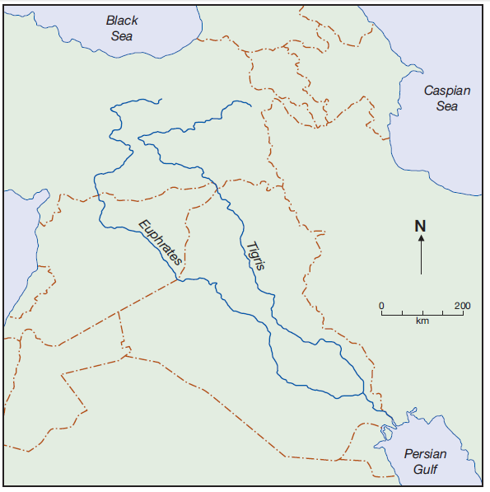The map shows the Euphrates and Tigris river system region

Why do you think conflict over water supply is likely?

____________________________________________________________________________________________________________________________________________________________________________________________________________________________________________________________________________________________________________________________________________________________________________________________________________________________________________________________________________________

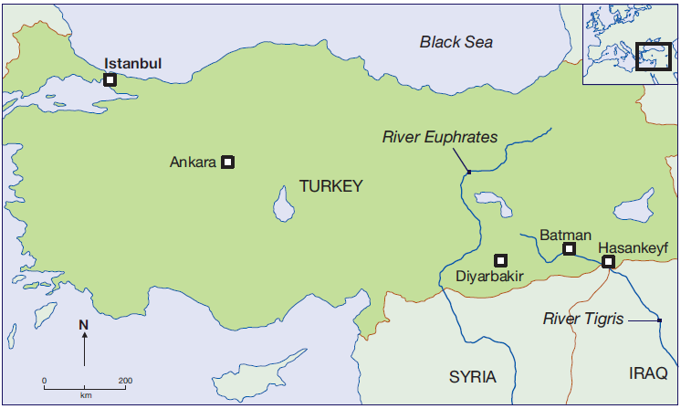

What is a dam? A dam is a barrier or structure across a stream, river or waterway to confine and control the flow of water.

As the world’s population and economy grows, demands for water increases. More dams are built to store water and supply power

The dam controls the water flow and so has impacts at its site and further downstream.

What could be the positive and negative effects on the landscape, water supply, power supply and river flow?

____________________________________________________________________________________________________________________________________________________________________________________________________________________________________________________________________________________________________________________________________________________________________________________________________________________________________________________________________________________________________________________________________________________________________________________________________________________________________________________________________________________________________________________________________________________________________________________________________________________________________________________

Case Study: Ilisu – A Disputed Dam

Under proposals to build an energy-generating dam in south-eastern Turkey, the ancient town of Hasankeyf on the Tigris River would be flooded. The town dates back to 10,000 years. Evidence of Roman, Ottoman and other cultures are still buried in the area. Caves carved out of Hasankeyf’s limestone cliffs one provided shelter and storage space for locals.

Hundreds, if not thousands, of historic sites in the areas have barely surveyed. These would be submerged by the large reservoir

Location:

River Tigris in south-east Anatolia, 65km upstream of Syria and Iraqi boarder

Dimension:

A rockfill dam 1820m long and 125m high will create a reservoir with the volume of 10.4 billion cubic meters and a surface area of 313km2

Main Benefits:

◊ Hydroelectric power

◊ Irrigation for local agriculture

◊ Boost for regional economy and development

◊ The new resettlement plans include funding to ‘rescue’ some parts of the town of Hasankeyf

by moving them elsewhere

Criticisms:

◊ 52 villages and 15 small towns will be flooded, including the city of Hanankeyf

◊ The homes and livelihoods of 15,000-20,000 people will be affected

◊ Threatens hundreds of ancient sites, including Kurdish and other archaeological heritage

◊ The dam will have a life of fifty to seventy years, but a beautiful site will be permanently destroyed

◊ The reservoir may encourage waterborne diseases like malaria to the region

◊ It will create Kurdish refugees-fuelling conflict between the Turkish state and the guerrilla of the PKK

◊ Will reduce the quantity and quality of water reaching Iraq and Syria, increasing tensions

◊ Resettlements plans will not help the people who lose their homes and livelihood, or save the hundreds of archaeological sites from being drowned

◊ The unity of the area would be destroyed by demolishing the town in the valley and moving some relics to another place

Each of your groups is going to represent a country affected by the dam. Using the information below, you need to write a short speech, to be given at a meeting of the government ministers if Turkey, Iraq and Syria.

|  |
| --- |
| File:Flag of Turkey.svg**Minister For Economic Development, Turkey**  ◊ The source of the river is in Turkey. It’s our river  ◊ Our water use is increasing and our population will increase by 50% by 2050 – We need to ensure there is enough water for everyone  ◊ We have spent billions of dollars to build dams for water storage and electricity generation  ◊ Syria and Iraq are wasteful of water and should start storing water – it doesn’t flow for free  ◊ Dams bring benefits to our people: clean drinking water, water treatment, power and roads  ◊ Iraqis benefit from both the Euphrates and Tigris running through their countries  ◊ We are making the biggest sacrifice – many people in Turkey will have to be relocated |
| **Minister for Agriculture, Syria**  ◊ The Trigris is a vital water supply for our people  ◊ We are only 30 miles downstream from this giant dam  ◊ Pollution from fertilizers and pesticides will increase down stream  File:Flag of Syria.svg◊ Turkey wants to build 22 dams on the Euphrates – it’s too many!!!  ◊ Turkey has both the Tigris and the Euphrates rivers – leave one alone!!!  ◊ If the project goes ahead we will lose half our water supply  ◊ They want to sell us the water which now runs freely in our country  ◊ We need our water for our agriculture. There are many farmers in our country |
| **Minister Of Reconstruction, Iraq**  ◊ We are furthest downstream and vulnerable to what happens further up  ◊ Dams in Turkey will cut off nearly 90% of the water that flows into Iraq  ◊ Syria has also built dams and that restricts a quarter of the river flow  File:Flag of Iraq.svg  ◊ We already have a huge problem of water supply: our rivers are strained, aquifers over-pumped and cities are parched  ◊ War has destroyed most of our water supply – we rely on river water for our needs  ◊ Our rivers are heavily polluted from upstream activities such as farming and sewage  removal  ◊ We have the right to some of the benefits of this dam – construction work, power and clean water |

My country is ____________________

You need to decide which points are the most powerful and pose some awkward questions for your neighbours...

______________________________________________________________________________________________________________________________________________________________________________________________________________________________________________________________________________________________________________________________________________________________________________________________________________________________________________________________________________________________________________________________________________________________________________________________________________________________________________________________________________________________________________________________________________________________________________________________________________________________________________________________________________________________________________________________________________________________________________________________________________________________________________________________________________________________________________________________________________________________________________________________________________________________________________________________________________

You are going to be regrouped so that there is a representative from each country in each group. Together you need to make a decision about the future of the Ilisu Dam scheme.

What Are The Impacts For Each Country?

|  |  |  |
| --- | --- | --- |
|  | POSITIVE | NEGATIVE |
| **TURKEY** |  |  |
| IRAQ |  |  |
| SYRIA |  |  |

Are There Any Other Major Water Supplies For The Countries?

|  |  |
| --- | --- |
|  | ALTERNATIVE WATER SUPPLY |
| TURKEY |  |
| IRAQ |  |
| SYRIA |  |

How Can The Scheme Be Altered To Resolve Any Conflicts?

Who ‘owns’ the water in a major world river?

If people have a *right* to the water that lies within their territory, what *responsibilities* do they have towards others using it further downstream?

____________________________________________________________________________________________________________________________________________________________________________________________________________________________________________________________________________________________________________________________________________________________________________________________________________________________________________________________________________________________________________________________________________________________________________________________________________________________________________________________________________________________________________________________________________________________________________________________________________________________________________________

**Bottled Water – Fact Or Opinion**

|  |  |  |  |
| --- | --- | --- | --- |
| **Rank** | **Country** | **Millions Of Gallons** | |
| **2002** | **2007** |
| 1 | America | 5,795 | 8,823 |
| 2 | Mexico | 3,898 | 5,885 |
| 3 | China | 2,138 | 4,787 |
| 4 | Brazil | 2,541 | 3,621 |
| 5 | Italy | 2,558 | 3,100 |
| 6 | Germany | 2,291 | 2,743 |
| 7 | Indonesia | 1,622 | 2,400 |
| 8 | France | 2,225 | 2,283 |
| 9 | Thailand | 1,277 | 1,533 |
| 10 | Spain | 1,191 | 1,284 |
|  | **World Total** | **34,594** | **49,869** |

In the space below draw a stacked bar graph of the inforamtion in the table above. Don’t foget to include all the appropriate titles:

Answer the following questions from the graph you have just drawn:

Why do you think these countries are the top ten to consume bottled water?

__________________________________________________________________________________________________________________________________________________________________________________________________________________________________________________________________________________________________________________________________________________________________________________________________________________________

Where there any counties you were surprised to see in this list or missing from this list? Why?

______________________________________________________________________________________________________________________________________________________________________________________________________________________________________________________

Which country has had the biggest increase in bottled water consumption?

­_______________

Which country has had the lowest increase in bottled water consumption?

_______________

What is the total percentage of these ten countries bottled water consumption of the world’s consumption?

_______________

Why do you think bottled water is so popular? Think about why people drink it here as well as abroad

__________________________________________________________________________________________________________________________________________________________________________________________________________________________________________________________________________________________________________________________________________________________________________________________________________________________

Around the bubble blow list the advantages and disadvantages of bottled water. Think about social, economic and environmental aspects:

Look at the table below, highlight whether you think their fact or opinion and explain why:

|  |  |
| --- | --- |
| http://www.wallpapers76.com/photo/7551/Cute-Cats-063.jpg | Cats Are Adorable  Fact ◊ Opinion ◊  ____________________________________  ____________________________________  ____________________________________  ____________________________________  ____________________________________ |
| The World’s Population Is 7,103,666,666,000  Fact ◊ Opinion ◊  ____________________________________  ____________________________________  ____________________________________  ____________________________________  ____________________________________ | http://www.andrew.cmu.edu/user/dbalan/Corporate%20Responsibility:Green%20Practices/group.jpg |
| http://1.bp.blogspot.com/-LK8BRZTBNjQ/TrqZqWq1adI/AAAAAAAAAIM/U6dQZNUlRt8/s1600/religion.jpg | All Religions Are Equal  Fact ◊ Option ◊  ____________________________________  ____________________________________  ____________________________________  ____________________________________  ____________________________________ |

Link the definitions to the correct key words:

|  |  |  |
| --- | --- | --- |
| **FACT** |  | Are not personal |
|  | Are usually not supported with quantifiable evidence |
|  | Lack bias (Impartial) |
|  | Can be confirmed using other sources |
| **OPINION** |  | Are personal |
|  | Are from reliable sources |
|  | Are usually supported with statistics |
|  | Show bias |

Read through the quotes below. Mark those that are fact with a ‘F’ and those which are an opinion with an ‘O’. Then colour each quote according to whether is linked to social, economic or environmental aspects:

|  |  |  |
| --- | --- | --- |
| Social | Economic | Environmental |

‘Nonsense. Bottled water doesn't 'damage the environment' any more than air freighting kiwi fruit from NZ or broccoli from Kenya or wine from Argentina.’

**Mr Jones** - **B.B.C.website forum**

‘While we have perfectly good tap water we spend approaching £2 billion on bottled water, when a billion people around the world don't have safe water.’

**Quote from a BBC Panorama programme**

‘I only drink bottled water; I’m worried about the impurities that are in tap water.’

**Mr Milner**

‘You can't take a tap out with you, so more consumers are swapping sweetened, high calorie beverages for bottled water, which can be consumed in adequate quantities to re-hydrate the body without adding calories to the diet.’

**NESTLE - Makers of Buxton and Vittel**

‘Based on an annual UK consumption of bottled water of 36 litres per person, the CO2 equivalent emissions created by this activity represents about 0.06% of the total daily emissions of an average British person.’

**DANONE - Makers of Volvic and Evian**

‘The UK water utilities' leak more water in less than a day than the UK's total annual consumption of bottled water (2.27 billion litres).’

**HIGHLAND SPRING**

‘Tap water was 500 times cheaper than bottled water.’

**David Owens- Thames Water**

‘The oil used to produce plastic water bottles in the UK would be enough to run 17,000 cars.’

**Daily Telegraph article**

‘Did you know that the carbon footprint of some brands of bottled water has been calculated to be at least 600 times greater than water from the tap?’

**Julie Hailes- New Green Consumer guide**

‘I can really taste the difference between tap and bottled water.’

**Mrs Marston.**

‘We would have to plant 57,000 trees a year to take in the carbon dioxide produced by the bottled water industry.’

**Lewis Smith- The Times Newspaper.**

‘It is immoral to import water from countries such as Tanzania, when many of the population don’t have access to clean water’.

**Mr Cassidy**

‘Buried water bottles can take up to 1,000 years to biodegrade.’

**Emily Arnold- People and Planet website**

‘A new report out today reveals that flavoured water contains as much sugar as a can of cola. So we've not just destroyed the planet, but the children's teeth, too.’

**, Judith Woods, Daily Telegraph article**

‘The bottled water industry employs over 2000 people in the United Kingdom.’

**Jill Ardagh, director-general of the Bottled Water Information Office**

Using the information you have just gathered write a speech for the class explaining whether you think bottled water is socially and environmentally immoral or not. Don’t forget to use facts to back up your opinion:

______________________________________________________________________________________________________________________________________________________________________________________________________________________________________________________________________________________________________________________________________________________________________________________________________________________________________________________________________________________________________________________________________________________________________________________________________________________________________________________________________________________________________________________________________________________________________________________________________________________________________________________________________________________________________________________________________________________________________________________________________________________________________________________________________________________________________________________________________________________________________________________________________________________________________________________________________________

**Water Aid**

|  |  |  |
| --- | --- | --- |
| http://www.adventure-travel-tales-and-tips.com/images/rain_in_africa.jpg | But say a prayer, pray for the other ones At Christmastime it's hard, but when you're having fun There's a world outside your window, and it's a world of dread and fear Where the only water flowing is the bitter sting of tears And the Christmas bells that ring there are the clanging chimes of doom Well tonight thank God it's them instead of you  And there won't be snow in Africa this Christmastime The greatest gift they'll get this year is life (Oooh) Where nothing ever grows No rain or rivers flow Do they know it's Christmastime at all? | http://img.timeinc.net/time/daily/2007/0709/africa_rain_0921.jpg |
| http://bp1.blogger.com/_vxYVpor0DT4/RoIkoyD2K0I/AAAAAAAAAog/lwV6kfpk5BA/s320/Snow+in+africa.jpg | http://farm5.static.flickr.com/4049/4702805759_63e9ce76ed.jpg |
| http://www.africanewsanalysis.com/wp-content/uploads/2010/09/Ivory-Coast-farmers-Nancy-Palus-IRIN.jpg |  |

So if Africa has so much water, why do we keep seeing headline like this:

|  |  |  |
| --- | --- | --- |
| Africa Has MASSIVE Problems | 1.1 Billion People Don’t Have Water | Clean Water, Or Lack Thereof, Plight For Many In Africa |
| Lack Of Water Threatens Millions In Horn Of Africa | Drought, Famine And Conflict: A Case From The Horn Of Africa | South Africa: Lack Of Water Access Undermining Rural Development |
| Poverty And Water Are Related |  | Africa Doughy Appeal Hits £72 Million |

List in the table below the human and physical impacts of lack of water:

|  |  |
| --- | --- |
| Human Impacts | Physical Impacts |
|  |  |

What is desertification?

Desertification is the processes by which an area becomes a desert usually through poor human management.

There are many short and long term ways to try to resolve desertification. In the table below sort the techniques to show which are which:

|  |  |
| --- | --- |
| Short Term Techniques | Long Term Techniques |
|  |  |

Fence off areas to stop animals grazing there

Refugee camps

Introduce drought resistant crops

Plant trees and bushes to provide cover for soil and stop it being blown or washed away

Medical aid

Rotate crops and water them using irrigation techniques

Food and clothing aid

Aid is a short term solution and includes refugee camps, medical aid, food and clothing. But have you thought about:

◊ Where does the aid come from?

◊ Does the aid reach the right people?

◊ What are the advantages and disadvantages of short term solutions?

◊ What happens to the people after the news stories and aid runs out?

______________________________________________________________________________________________________________________________________________________________________________________________________________________________________________________________________________________________________________________________________________________________________________________________________________________________________________________________________________________________________________________________________________________________________________________________

In pairs, number the statements in order of which you most agree with (1) to those you lest agree with (9):

**Will Our Water Run Out?**

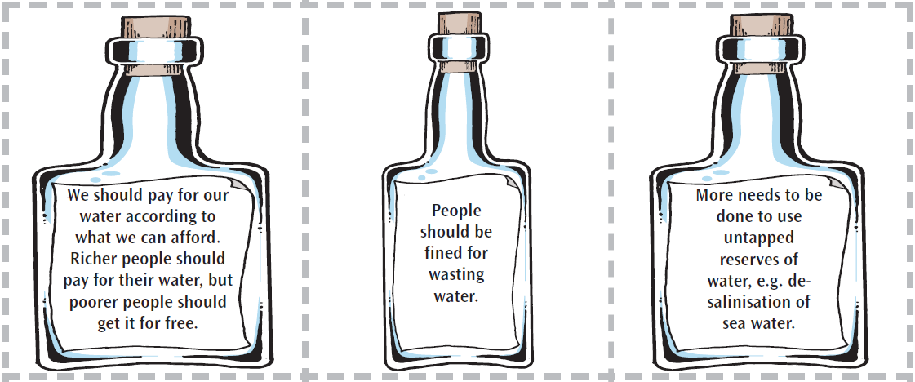

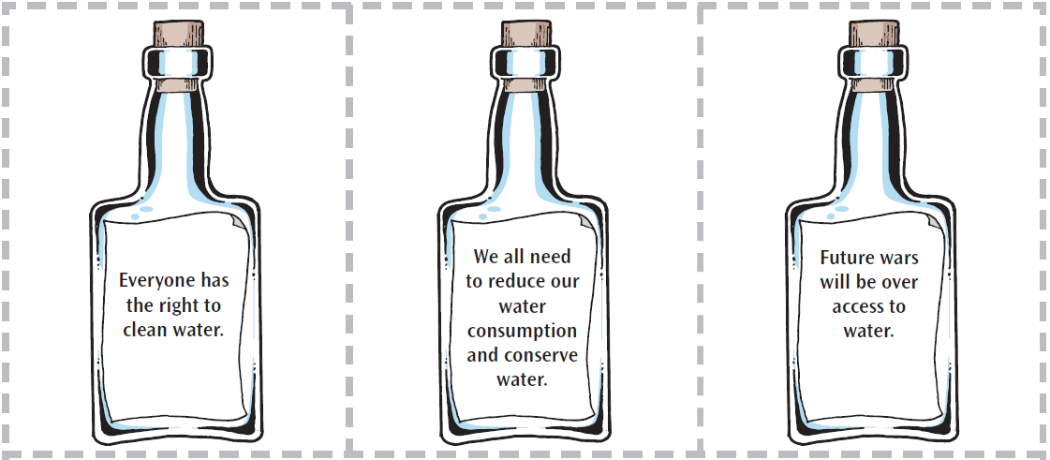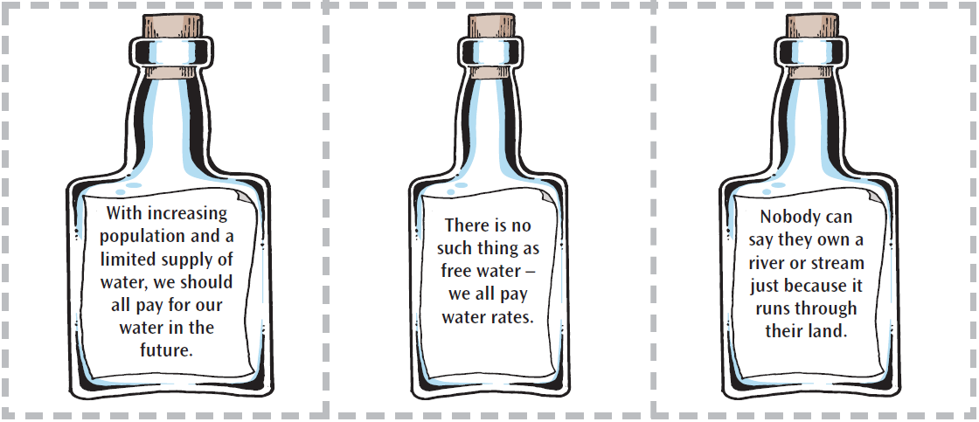

Is meeting demand more important than reducing it?

____________________________________________________________________________________________________________________________________________________________________________________________________________________________________________________________________________________________________________________________________________________________________________________________________________________________________________________________________________________________________________________________________________________________________________________________________________________________________________________________________________________________________________________________________________________________________________________________________________________________________________________

Imagine what could happen to water demand and supply in your local area by 2050. What might the local water company mission statement say then?  
  
Write a letter, set in 2050, describing one of the two possible futures:  
  
1) Where demand for water has risen unchecked.  
How would water be used?  
Where would it come from?  
What might the impact be – on cost and on the environment?  
  
2) Where water is carefully conserved.  
How might life be different?  
How would water conservation be achieved?  
How much would it cost and would it be affordable to all?

________________________________________________________________________________________________________________________________________________________________________________________________________________________________________________________________________________________________________________________________________________________________________________________________________________________________________________________________________________________________________________________________________________________________________________________________________________________________________________________________________________________________________________________________________________________________________________________________________________________________________________________________________________________________________________________________________________________________________________________________________________________________________________________________________________________________________________________________________________________________________________________________________________________________________________________________________________________________________________________________________________________________________________________________________________________________________________________________________________________________________________________________________________________________________________________________________________________________________________________________________________________________________________________________________________________________________________________________________________________________________________________________________________________________________________________

